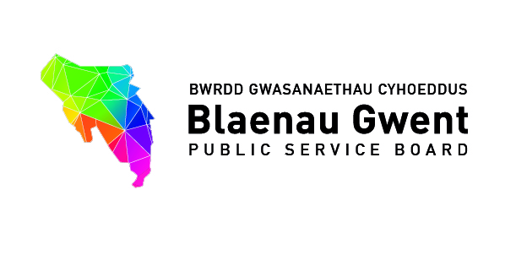

Special Blaenau Gwent Public Service Board

One Item Agenda on Well-being Planning

To be held: Tuesday 21st March 2017 (2.00pm – 4.00pm)
Venue: Executive Room, Civic Centre, Ebbw Vale, NP23 6XB

1. Welcome, introductions and Apologies Chair [5 mins]

For information
2. Blaenau Gwent Draft Well-being Assessment (presentation) Andrew Parker [15 mins]
- Process for developing our the first draft assessment
- Overview of structure and content of draft assessment product put out for formal consultation.

For action\decision
3. Progress on developing the Well-being Assessment for Blaenau Gwent
(paper attached) Paul Symes [10 mins]

For action\decision\recommendation
4. Formal Consultation on the Draft Well-being Assessment for Blaenau Gwent
(presentation) Emma Scherptong [20 mins]
- Overview of formal consultation
- Future Generation Commissioner for Wales response (paper attached)
- Welsh Government response (paper attached)
- Blaeanu Gwent PSB Scrutiny Committee response (paper attached)
- Responding to the formal consultation process

For action\decision\recommendation
5. Setting Indicative Priorities for the Blaenau Gwent PSB Paul Symes [45 mins]
a) The prioritisation process (Paper attached Report, Section 1.10 – Appendix A)
b) Agreeing indiciative priorities for starting response analysis (discussion)

For action\decision\recommendation
6. Resourcing the Proposed Approach Paul Symes [15 mins]
a) Finalising and publishing a well-being assessment
b) Response analysis to support objective setting

7. Summary of the next steps for PSB Andrew Parker [5 mins]
a) Publishing a final assessment
b) Setting well-being objectives

8. Any other Business Chair [5 mins]

9. Items for information (papers attached)
- Summary of the Blaenau Gwent We Want public engagement programme 2016
- PSB Winter Bulletin 2017
- Funding to support PSBs 2017/18
- Invest to Save Opportunities for PSB consideration.
- Measuring Inequalities in Britain (What Works Wellbeing, March 2017)

10. Date of next meetings:

- 24th April, Civic Centre, Executive Room (10.00am – 12.00pm)
- 2017/18 Schedule

Date | Venue | Time
**Special PSB**  - Includes facilitated session on impact on changes to Welsh Government’s Resilient Communities Anti-Poverty Programmes Communities First  Week commencing 24th April 2017 | Civic Centre, Executive Room | 10.00am – 12.00pm
12th July 2017 | Civic Centre, Executive Room | 2.00pm to 4.00pm
10th October 2017 | Civic Centre, Executive Room | 2.00pm to 4.00pm
16th January 2018 | Civic Centre, Executive Room | 2.00pm to 4.00pm
13th March 2018 | Civic Centre, Executive Room | 2.00pm to 4.00pm

