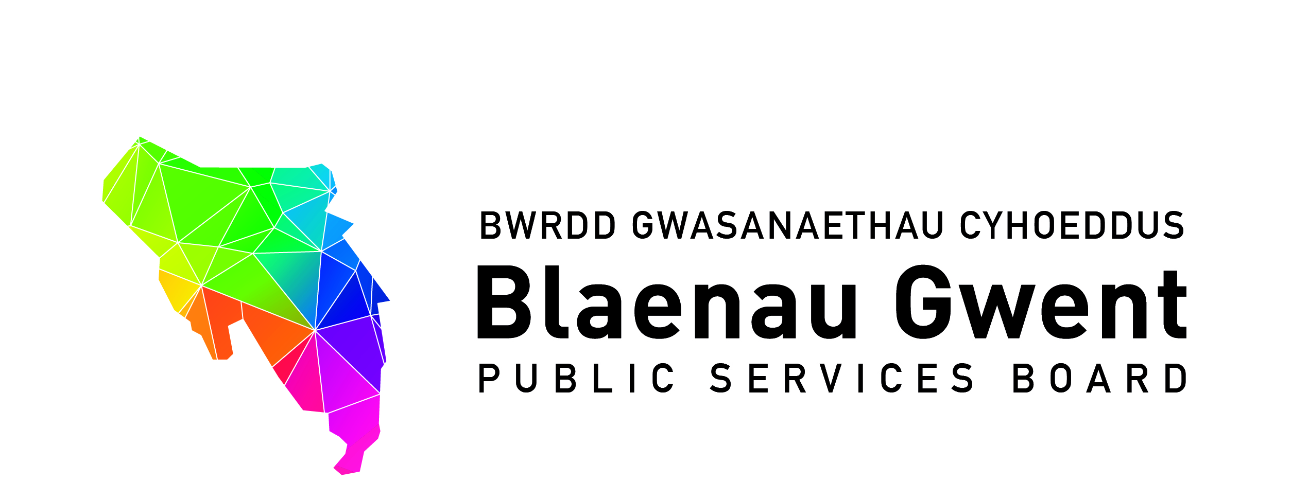

Blaenau Gwent Public Services Board

To be held: Monday 22nd October (14.00pm – 16.00pm)

Venue: Civic Centre, Municipal Offices, Ebbw Vale, Blaenau Gwent. NP23 6XB

1. Apologies (Chair)

2. Notes of previous meeting (Chair) (15 mins) (papers attached)
a) PSB meeting 23rd July 2018 notes for accuracy
b) Action Sheet from 23rd July 2018
c) Recommendations from PSB Strategic Support Group
- Endorse the Blaenau Gwent Well-being Plan Easy Read Version
- Endorse the PSB News Bulletin (First Edition) (attached)
- Recommendation on Agenda Item 7

3. Director of Public Health Annual Report 2018: A Healthier Future for Gwent – Overview Presentation by SA (10 mins) (report attached)

Part I: DISCUSSION SPACE (55 mins)

4. Blaenau Gwent Well-being Delivery Plan Lead Updates (papers attached)
For action\decision
a) Early Years First 1000 Days Programme (GJ)
b) Maximising Opportunities for Prosperity (MM) (Copy to follow)
c) Working together on Universal Credit (JL) (Copy to follow)
d) Getting Blaenau Gwent Active and Healthy (BE) (Copy to follow)

e) Carbon Positive Futures presentation (JG & Fen Turner) (paper attached)
f) Discussion Space options at next PSB meeting (5 mins)
- Gwent Futures (Ash Wales) – Proposal for joint PSB and SSG workshop to be held (13.00pm – 15.00pm); PSB business (15.00pm – 16.00pm);

Part II: PSB PARTNERSHIP BUSINESS

5. Performance Management (10 mins)
For information
a) Progress update on Strengthening PSB Partnerships and Groups for Delivery (MF)

For action/decision
b) PSB Scrutiny Forward Work Programme – to agree items to be proposed for 3rd December meeting (BE)

6. Partnership Business (Chair) (10 mins)
For action/decision
a) Future Generations Commissioner & Children’s Commissioner Letter to
PSBs (proposed response attached)
b) Academi Wales PSB Board Development – Option for workshop at Jan PSB meeting
(Letter to PSB Chairs attached) (BE)
c) Partner Attendance at Equalities and Human Rights Commission Evening Event –
Tuesday 4th December

7. Commissioning (JG) (papers attached) (10 mins)
For action\decision
a) Recommendation for Natural Resources Wales Funding (£5,000) to support delivery of
local well-being plans
b) Update paper on Enabling Natural Resources and Well-being in Wales Grant

8. Key Information from Regional Working Partnerships and Groups (BE) (10 mins)
For information
a) GSWAG Updates
- Good Practice Exchange Wales GSWAG Vlogs Collaborative Partnerships and Keeping Data Live
- Gwent Futures Conference Invitation, 12th November (Invite attached)

9. Diary Markers for PSB Members (papers attached)

10. Any Other Business (Chair)

11. Items for information
a) PSB Strategic Support Group Notes - August 2018
b) Violence Against Women, Domestic Abuse and Sexual Violence (VAWDASV) Annual Report 2018 (paper attached)

12. Date of next meeting
a) January date to be discussed

