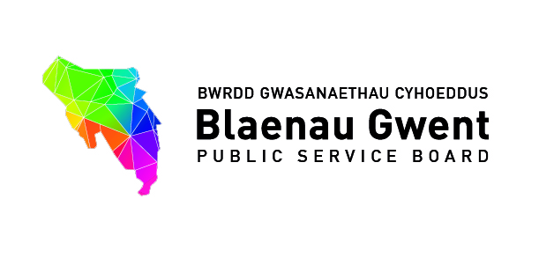
Blaenau Gwent Public Service Board
Agenda

To be held: 31st October 2016 (2pm - 4pm)
Venue: Executive Room, Civic Centre, Ebbw Vale, NP23 6XB

- Welcome, introductions and Apologies (Chair)

- Notes of July 2016 meeting & Summary Action Sheet (papers attached)

- Well-being of Future Generations Act

- Blaenau Gwent Public Services Board Arrangements

For action\decision\recommendation

- Confirmation of PSB Chairing & proposal to nominate Vice Chair
- PSB Membership – involving other partners (paper attached)
- PSB Strategic Support Group – PSB to consider appropriate Membership (terms of reference copy to follow)
- Future Generations Commissions invitation to attend BG PSB (21st March 2017)
- Creating a Purposeful PSB (PS)
- Initial findings & Welsh Government guidance (papers attached)
- Proposal for Special PSB session to be held 12th December to consider next steps

For awareness\discussion

- Update on PSB Scrutiny arrangements (Report to Council attached)
- Letters to PSBs (Letters & guidance attached)
- Older People’s Commissioner – New Guidance for Public Service Boards
- Joint letter: Children’s Commissioner & Future Generations Commissioner – Embedding Children’s Rights for future generations

- Wellbeing Assessment (WBA)

For awareness\discussion

- Verbal update GSWAG – Draft Regional WBA & Blaenau Gwent PSB Wellbeing Assessment (BE/PS)
- Invite to Special PSB SSG (25th November) – developing the format of a local Wellbeing Assessment

For information

- Welsh Government Wellbeing Assessment Conference – Nant Garw, 14th November (Blaenau Gwent PSB fully represented)

- Communications & Engagement

- PSB Communications Plan

For action\decision

- PSB Communications Plan – Nominations of Communications contact from the Board for task & finish group to develop draft for PSB January
- Verbal update on PSB Website (BE)

- BG We Want – progress update and next steps (short presentation)

- Partnership Business

For awareness\discussion

- Update on Communties First Programme (Martin Featherstone) (Ministerial Statement attached)
http://gov.wales/newsroom/people-and-communities/2016/new-approach-needed-to-build-resilient-communities/?skip=1&lang=cy

- Update on Local Government Reform (Stephen Gillingham) (Ministerial statement attached)

http://gov.wales/newsroom/localgovernment/2016/reform-local-government/?skip=1&lang=cy

- Partner Organisation Business

Anuerin Bevan University Health Board (Eryl Powell, Public Health Wales)
(Presentation 20 minutes)

- Improving Our Oral Health Plan
- Annual Report of the Director of Public Health - Sustainable Health for Future Generations

- Single Integrated Plan Delivery

For action
- SIP Annual Report for PSB sign off prior to Welsh Government submission (attached) (PS)

For awareness\discussion

- People & Places Highlight Report (copy to follow) (Martin Featherstone)

- Items for information (papers attached)

- PSB Bulletin – Autumn 2016
- New OPCW Guidance for Public Service Boards
- Welsh Government (Social Research Team) - Publication of research report: Exploring the use of evidence and measurement of impact in relation to childhood obesity specifically and using this to inform lessons for public services more generally
http://gov.wales/statistics-and-research/approaches-understanding-outcomes-impact-welsh-public-services/?skip=1&lang=cy

- Welsh Government: European Funds Team Audit of Blaenau Gwent Local Services Board Support Project (email)

- Any other Business

- Date of next meetings:

- 30th January 2017 2pm - 4pm Executive Room, Civic Centre

- Proposed 2017/18 Schedule

Date | Venue | Time
**Special PSB**  12th December 2016  To be confirmed | Civic Centre, Executive Room | 2.00pm to 4.00pm
30th January 2017 | Civic Centre, Executive Room | 2.00pm to 4.00pm
**Special PSB for formal sign off of BG Well-being Assessment & Draft Well-being Objectives**  21st March 2017 | Civic Centre, Executive Room | 2.00pm to 4.00pm
12th July 2017 | Civic Centre, Executive Room | 2.00pm to 4.00pm
10th October 2017 | Civic Centre, Executive Room | 2.00pm to 4.00pm
16th January 2018 | Civic Centre, Executive Room | 2.00pm to 4.00pm
13th March 2018 | Civic Centre, Executive Room | 2.00pm to 4.00pm

