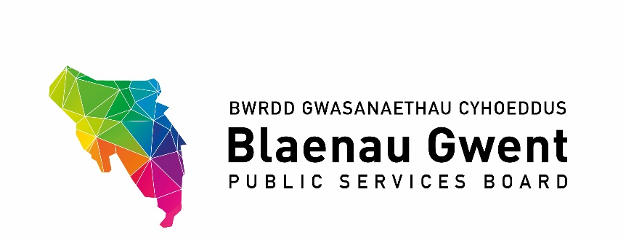

Blaenau Gwent Public Services Board

To be held: Monday 21 September 2020, 9:30 – 11:30am
Venue: Microsoft Teams meeting
Chair: Cllr Nigel Daniels

Agenda

- Welcome & apologies (Chair)

- Notes of Previous Meeting (Chair)
a) PSB Meeting Notes – 20 Jan for accuracy (Chair)
b) Action Sheet – 20 Jan (BE)

- Recommendations from other groups
- SSG
- Regional Groups:-
- G10 Regional PSB paper (draft attached)
- GSWAG
- Gwent Travel Charter (paper attached)

PART 1 – DISCUSSION SPACE

- PSB Strategic Work Programme 2020/21 Position Statements (paper attached)
- Blaenau Gwent Sustainable Food Programme (HT, Tai Calon)
- Climate Change – Mitigation (MM, BGCBC)
- Climate Change – Adaption (JG, NRW)
- Integrated Well-being Network (GJ, ABUHB)
- First 1,000 Days (GJ, ABUHB)
- Age-Friendly Communities (TBC – ST, GAVO proposed)
- Community Safety Hub (Gwent Police)
- Foundational Economy (GL, Coleg Gwent)

- NRW Strategic Allocated Funding for PSBs (papers attached)

- PSB Annual Report 2019/20 (paper attached)

PART 2 – PARTNERSHIP BUSINESS

- BGCBC Covid19 Recovery Themes – Update on Current Position (verbal – MM)

- Agenda Items for Next Meeting from Partners

- Items for Information
- Written Communications with WG Minister for Local Government & Housing (letters attached)
- Welsh Government Strategic Review of Partnerships (paper attached)
- Future Generations Commissioner’s Annual Report 2019/20

- Any Other Business

- Dates for the Next Partnership Meetings
- Monday 30 November 2020 OR Monday 14 December 2020
- Monday 8 March 2020

