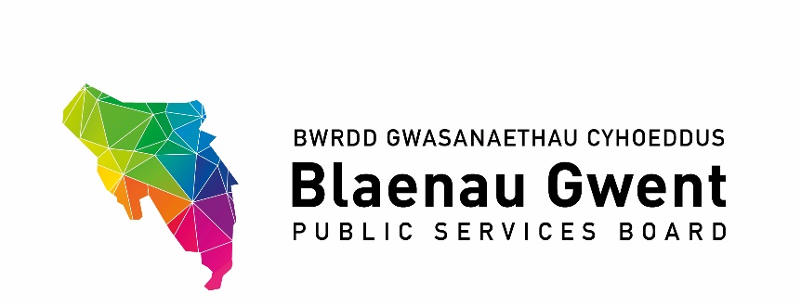

Blaenau Gwent Public Services Board

To be held: Monday 8 March 2021, 2 – 4pm
Venue: Microsoft Teams meeting
Chair: Cllr Nigel Daniels

Agenda

- Welcome & apologies (Chair) (5 mins)

- Notes of Previous Meeting (Chair) (10 mins)
a) PSB Meeting Notes – 30 November 2020 for accuracy (Chair) (paper attached)
b) PSB Action Sheet – 30 November 2020 (AP) (paper attached)

- Recommendations from other groups (10 mins)
- PSB Scrutiny Committee (SH)
- SSG (AP)
- Regional Groups: G10 Gwent Regional PSB arrangements (MM) (paper attached)

PART 1 – DISCUSSION SPACE

- PSB Strategic Work Programme 2020/21 (50 mins)
- Early Years Transformation Programme (GJ) (paper attached)
- Foundational Economy (BMc) (paper attached)
- Age-Friendly Communities (ST) (paper attached)
- Climate Change – Mitigation (MM) (paper attached)
- Blaenau Gwent Sustainable Food Programme (HT) (paper attached)

PART 2 – PARTNERSHIP BUSINESS

- a) PSB Engagement Sub-Group Annual Review (AP) (paper attached) (10 mins)

- Police & Crime Commissioner for Gwent Commissioning Services Update (JC) (paper attached) (5 mins)

- NRW Woodland Creation Opportunity: Repurposing Public Sector Land (JG) (5 mins)

- Funding for 2021/22 (AP) (10 mins)
- Participatory Budgeting (paper attached)
- NRW Strategic Allocated Funding for PSBs
- GSWAG Regional PSB Grant for Welsh Government

- Agenda Items for Discussion Space and Next Meeting from Partners
- Regional Gwent PSB
- Covid19 Recovery

- Items for Information (5 mins)
- SSG minutes 14th January 2021 (paper attached)
- Adverse Childhood Experiences Closure Report (RBW) (paper attached)
- Gwent Police Overview of Community Safety Hub Survey Results (AT) (paper attached)

- Any Other Business

- Date for the Next Partnership Meeting
- Monday 7 June 2021

