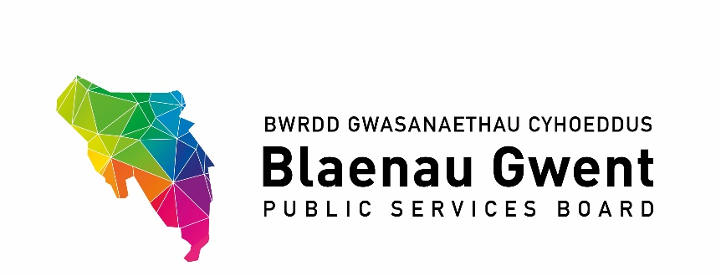

Blaenau Gwent Public Services Board Meeting

To be held: Monday, 20 January 2019 (2.00 p.m. – 4.00 p.m.)

Venue: Executive Room Civic Centre, Ebbw Vale

1. Welcome and Apologies (Chair)

2. Notes of Previous Meeting (Chair) (papers attached) (5 Mins)

a) PSB Meeting Notes – 14 October 2019 for accuracy (Chair)
b) Action Sheet – 14 October 2019 (BE)

3. Recommendations from other groups: (10 mins)

- PSB Scrutiny (Councillor Healy)
- G10 (BE)
- GSWAG (BE)

PART 1 – DISCUSSION SPACE (1 hr 30 mins overall)

4. Well-being Plan Delivery Plan

- Inception Reports (15 mins per item)

For action\decision

- Climate Change – BGCBC (MM)
- Blaenau Gwent Sustainable Food Programme Tai Calon / PHW (JL)
- Foundational Economy- BGCBC (MM)
- Early Years First 1000 Days Programme ABUHB (GJ)
- Integrated Well-being Networks (SA)

- Progress reports (5 mins)
- Age Friendly Communities (BE)
- Community Safety Hub – (Gwent Police)

- Performance Management Framework (BE) (5 mins)
- Public Services Board Development – WAO Review (BE) (5 mins)

PART 2 - PARTNERSHIP BUSINESS (15 mins overall)

For consideration under Community Safety Partnership Powers

5. Community Safety and Youth Offending Contributions – Gwent PCC (JR) (10 mins)

6. Agenda Items from partners for next meeting (Chair)

7. Items for information (Chair)

- PSB Strategic Support Group Notes 7 November 2019
- GSWAG Notes- 5 December 2019

8. Any Other Business (Chair)

- The Power of New Ideas – Future Generation Xchange (MM)

9. Date of Next Meeting 20 April 2020

