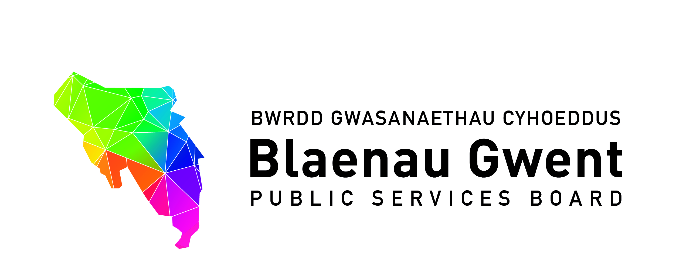
Blaenau Gwent Public Services Board - Notes
Monday 30th October 2017 (11:00 – 13:00)
Tai Calon (Board Room), Solis One, Rising Sun Industrial Estate, Blaina
In attendance:
Councillor Nigel Daniels (Chair) | Blaenau Gwent County Borough Council
Michelle Morris | Blaenau Gwent County Borough Council
Dewi Jones | South Wales Fire and Rescue Service
Guy Lacey | Coleg Gwent
Joe Logan | Tai Calon
Glyn Jones | Aneurin Bevan University Health Board
Martin Featherstone | GAVO
Michael Evans | Natural Resources Wales
Jeff Cuthbert | Police and Crime Commissioner
Neil Taylor | Office of the Police and Crime Commissioner
Nick McLain | Gwent Police
Sarah Aitken | Public Health Wales
Andrew Parker (PSB Support) | Blaenau Gwent County Borough Council
Bernadette Elias (PSB Support) | Blaenau Gwent County Borough Council
Carol Carroll (PSB Support) | Blaenau Gwent County Borough Council

Apologies:
Huw Jakeway | South Wales Fire and Rescue Service
Judith Paget | Aneurin Bevan University Health Board
Phil Robson | Aneurin Bevan University Health Board
Diana Binding | Wales Probation Service
Julian Williams | Gwent Police
Rhodri Asby | Welsh Government

1. Welcome, introductions and apologies

The Chair welcomed everyone to the meeting and introduced Michelle Morris in her new role as Managing Director of Blaenau Gwent County Borough Council. He also expressed his thanks on behalf of the PSB to Stephen Gillingham for all the work he had done in the role of Temporary Head of Paid Service for the Council.

2. Notes of previous meeting

2. (a) PSB meeting 24th July for accuracy
The notes were agreed as accurate.
2. (b) Summary Action Sheet
BE advised that all actions were complete with the exception of the ‘Update on Domestic Homicide Review’ which would be tabled at a future PSB meeting.
Action 1: Update for future meeting on DHR from Rebecca Haycock (VAWDASV)
2. (c) Request for notes of PSB meetings to be included on the PSB Scrutiny Committee agenda
The members agreed that notes of the PSB meetings should be included in the information pack for the Public Services Board Scrutiny Committee as requested by the Committee. BE outlined that the next scrutiny meeting would be held on 5th December, and an invite will be sent on behalf of the chair of Scrutiny Committee to PSB members.
Action 2: PSB members to be invited to the PSB Scrutiny Committee
2. (d) Recommendations from the PSB Strategic Support Group held on 20th October
- Blaenau Gwent We Want Engagement Programme is put forward for recognition where relevant;
- Suggestion for a future PSB discussion space – Planning for the Tech Valley Initiative.
The PSB supported the Blaenau Gwent We Want Engagement Programme being put forward for recognition where the opportunity arose, noting that the Future Generations Commissioner has already provided positive feedback on the programme.
It was agreed that the Tech Valley Initiative would be included for next discussion space. The Chair welcomed this opportunity to discuss how the PSB can maximise the benefits of the initiative

Action 3: BE to include on the next PSB agenda
3. Discussion Space
3. (a) Blaenau Gwent We Want Engagement Programme. Overview of Phase 3 Analysis and Phase 4 proposed approach (AP)
AP gave an overview of the document for discussion and feedback.
MM commented that it was an excellent document, in an accessible format to encourage public feedback and input.
The PSB had a general discussion on maximizing the opportunities to encourage on-going participation.
JC outlined the opportunities that present from regional working relating to engagement activity.
BE commented that the regional project on Happy Communities funded by the PSB Regional Support Fund for 2017/18 was being progressed via GSWAG (Gwent Strategic Well-Assessment Group), providing an opportunity for regional alignment.
It was raised that the Future Generations Commissioner had not yet attended a Blaenau Gwent PSB meeting and BE said that she would make contact to invite her.
Action 4: PSB requested BE to contact the Office of the Future Generations Commission to invite the Commissioner to a future PSB meeting
3. (b) PSB to provide comment on the Draft Well-being Plan
The discussion was framed around seven key questions and initial feedback was given on the well-being plan. Overall, the PSB welcomed the format and content of the plan.
ME commented that it was an accessible document and an easy read.
ME and NMc noted two small points of factual accuracy and both would provide amendments to the Partnerships Team prior to the commencement of the formal consultation.
Action 5: ME and NMc to provide amendments to Partnerships Team
BE noted that the formal consultation period would run until Sunday 21st January 2018.
3. (c) Consideration of next discussion space topic for next meeting
Initial suggestions:
- Discussion on developing the PSBs own internal well-being objective
- Interaction with PSB Scrutiny Committee and function

For timeliness it was agreed at the Tech Valley Initiative would be the Discussion Space item for the next meeting.

JC suggested that a future discussion space would need to consider the well-being Plan to provide clarity on the lead responsibilities for the delivery of the plan.

4. Partnership Business
4. (a) People & Places. Q1 update against Single Integrated Plan
MF gave an update to the meeting, and following discussion it was agreed that it would be helpful for a final position statement against the SIP to be produced, and where actions were not closed or progressed this should be discussed at People and Places meeting to help inform the transition to the well-being plan.
Action 6: MF and BE to discuss at the next People and Places Meeting
4. (b) Advice note from the Future Generations Commissioner for Wales
MM suggested it would be helpful if the PSB Strategic Support Group (SSG) should consider the key messages of the Advice Note. Members agreed with this approach given the level of detail, and in keeping to the approach of involving partners through SSG.
Action 7: SSG to consider the key messages of the Advice Note
4. (c) Potential for a Gwent PSB – Initial discussion
MM asked the members for views on a Gwent-wide approach for PSB. Advantages considered were fewer PSB meetings to attend, more integration with other authorities and a natural progression for PSB. Possible disadvantages included losing local focus on issues that are important to Blaenau Gwent, there would still need to be capacity at the local level to drive forward delivery, and assurance of appropriate governance arrangements to a move regional approach.
BE also noted there were a number of regional partnerships e.g. Safer Gwent, Area Planning Board, and the Greater Gwent Health, Social Care and Well-being Partnership, which needed to be mapped and reflected in PSB arrangements.
Action 8: MM to discuss feasibility with other Chief Executives informally, and feed in PSB comments.
4. (d) Welsh Government Regional Fund Grant Progress Update – Happy Communities and Futurology Project (BE)
BE updated the meeting noting that the GSWAG (Gwent Strategic Well-Assessment Group) were leading on the delivery of the Regional Fund Grant.
The Happy Communities Project was underway with the Bristol-based Social Enterprise Happy Cities securing the contract. Regional training relating to elements of the project were due to be held in November, with a Happiness Pulse survey due to be launched as a pilot in the new year.
The tender for the delivery of ‘futurology’ research had recently closed with four companies submitting a tender. Tender evaluation, hosted by Caerphilly Council, was being held on 31st October, with AP attending on behalf of Blaenau Gwent.

5. Any other Business
No further business was noted at this point.

6. Items for information only
- Welsh Government Legacy Funding and Communities First Transition Update
- Gwent Strategic Well-being Assessment Group (GSWAG) Meeting Notes (July 2017)
- PSB Strategic Support Group Notes – 19th July 2017 & 5th September 2017
- Independent Review Panel - Get involved! Review of the Community and Town Council Sector (previously circulated)
- Torfaen PSB Draft Well-being Plan

7. Date of next meeting:
BE noted that due to the consultation period on the draft well-being plan running until 21 January 2018, the next PSB meeting would need to move from 16 January.
Date | Venue | Time
16th January 2018 | Offers invited to host meeting | 14:00 – 16:00

Action 9: BE to advise of next PSB meeting

