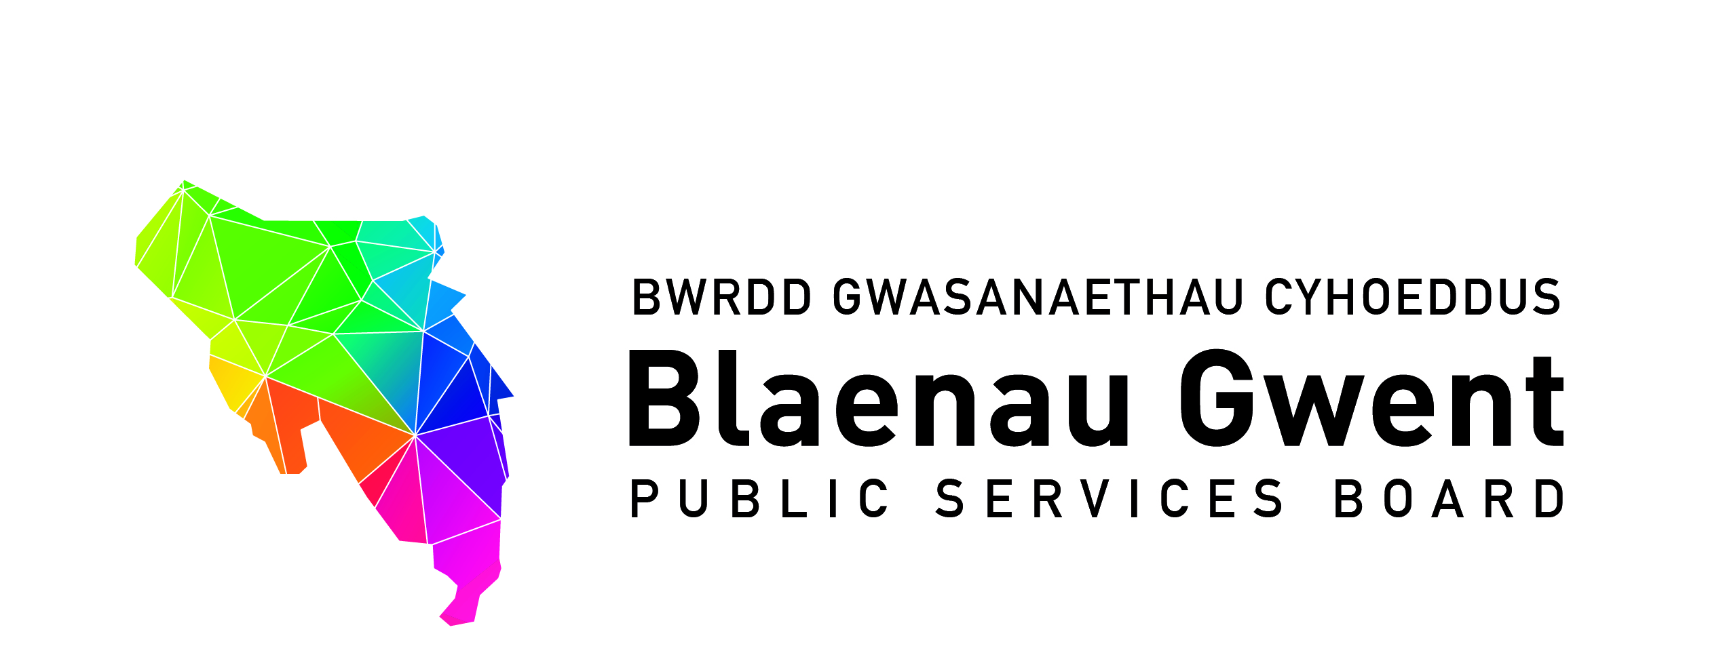

Blaenau Gwent Public Services Board

To be held: Monday 23rd July (11.00am – 13.00pm)

Venue: Llanhilleth Miners Institute, Meadow Street, Llanhilleth, NP13 2JT

1. Apologies (Chair)

2. Welcome Sophie Howe, Future Generations Commissioner – opening conversation with PSB (Chair) (30 mins)

3. Launch of the Well-being Plan at ‘Go Wild’ (BE) (5 mins)

4. Notes of previous meeting (Chair) (10 mins) (papers attached)
a) PSB meeting 26th April notes 2018 for accuracy
b) Action Sheet from 26th April 2018
c) Recommendation from PSB Strategic Support Group

5. Blaenau Gwent Well-being Delivery Plan Lead Updates (30 mins) (papers attached)
a) Early Years First 1000 Days Programme (GJ)
b) Getting Blaenau Gwent Active and Healthy (SA/EP)
c) Working together on Universal Credit (JL)

6. Discussion space - Collaborative Ways of Working (MF) (30 mins)
a) Overview of Opportunities for Strengthening Partnerships Structures and Groups for Delivering, with recommendations for PSB

7. Key Information from Regional Working Partnerships and Groups
(10 mins) (papers attached)
a) Safer Gwent proposal paper - meeting statutory requirements for Community Safety (JC/NT)
b) GSWAG Updates (BE)

8. PSB meeting (Chair) (5 mins)
a) Proposals for changes to the agreed PSB meetings for 2018/19
- Monday 22 October 2pm-4pm
- Monday 22 January 2pm-4pm

9. PSB Dates for 2018 Diary (Chair)
a) Saturday 22nd September – Armed Forces Community Covenant: Reaffirmation Parade and VC Stone for John Henry Williams, Brynmawr & Nantyglo (10.00am to 2.30pm)
b) Gwent Future Conference Autumn 2018

10. Any Other Business (Chair)

11. Items for information
a) Gwent Strategic Well-being Assessment Group Draft Notes – June 2018
b) PSB Strategic Support Group Notes - May 2018
c) National Assembly for Wales: Equalities, Local Government and Communities
Committee (07/06/18) – Inquiry into Public Services Boards Transcript
d) Welsh Government PSB Bulletin – Spring 2018

