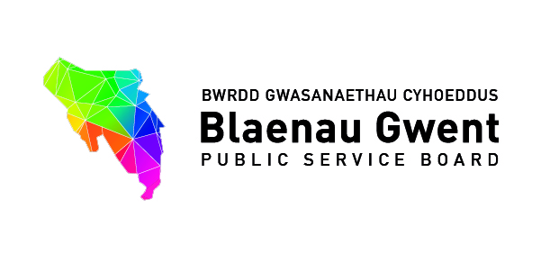
Blaenau Gwent Public Service Board
Agenda

To be held: 30th January 2017 (2pm - 5pm)
Venue: Executive Room, Civic Centre, Ebbw Vale, NP23 6XB

1. Welcome, introductions and Apologies [Chair]
10 mins

For action\decision\recommendation

- PSB Vice Chair to be agreed

2. Notes of Oct 2016 meeting for accuracy & Summary Action Sheet (papers attached) 10mins

- Verbal feedback on PSB Development Session – Creating a Purposeful PSB (papers attached) [Stephen Gillingham]

3. Partnership Business
30mins

For discussion

- Engagement Process with PSB on Resilient Communities – Anti-poverty Programme
(Jo-Anne Daniels, Director of Communities & Tackling Poverty, Welsh Government)

- Briefing report – Communities First (paper attached) [Richard Crook]

4. Well-being of Future Generations Act
20mins

- Wellbeing Assessment (WBA)

For action\decision\recommendation

- Formal consultation process –First Draft Blaenau Gwent PSB Well-being Assessment prior to Section 38 Consultation Report (paper attached) (demonstration) [Paul Symes]

For information

- Briefing report - Welsh Government Wellbeing Assessment Conference – Nant Garw, 14th November (paper attached) [Emma Scherptong]

5. Partner Organisation Business
50 mins

For awareness\discussion

- Presentation on State of Nation Report
[Michael Evans, Natural Resources Wales] (15 minutes)

- Presentation on Adverse Childhood Experiences in Wales
&
Presentation on Making a Difference
[Dr Gill Richardson, Public Health Wales] (30 minutes)

- Verbal update - GAVO Strategic Plan (paper attached) [Martin Featherstone]

6. PSB Performance management
10mins

- Briefing report on PSB Performance Management with recommendations from PSBSSG (paper attached) [Bernadette Elias]

7. Single Integrated Plan Delivery
20mins

For action\decision\recommendation

- People & Places – Progress update (Martin Featherstone) (copy to follow)

- Cover report & Final Drafts Thematic Partnership Action Plans 2016 / 17 / 18
for sign off (papers attached)

- Learning
- Healthy
- Fair and safe
- Thriving & vibrant (copy to follow)

- Response on Oral Health from People & Places – PSB to consider recommendations (paper attached) [Eryl Powell] (copy to follow)

For information

- Armed Forces Community Covenant & Strategy for Older People – Progress update (papers attached) [Emma Scherptong]

8. Communications & Engagement [Bernadette Elias]
10 mins

For action\decision
- Formal procedure for contacting the PSB (papers attached)

9. Process on PSB Meeting Business & Requests for Agenda Items [Stephen Gillingham]
10 mins

- The Development of a Health and Well-being Centre in Tredegar - ABUHB
- Out of Hours Service Change – ABUHB

10. Items for information (papers attached)
5 mins

- Review of the National Standards for Community Health Councils
http://www.wales.nhs.uk/sitesplus/899/home
- Community Development Council in Wales – Letter received
- PSB Briefing Note (October 2016)
- A catalyst for the Well-being of Wales – Future Generations Commissioner
- Talking Future Generations Report – Future Generations Commissioner
- Children’s Zones – Letter for bids

11. Any other Business
5 mins

12. Date of next meetings:

- 21st March
- Proposed 2017/18 Schedule

Date | Venue | Time
**Special PSB for formal sign off of BG Well-being Assessment & Draft Well-being Objectives**  21st March 2017 | Civic Centre, Executive Room | 2.00pm to 4.00pm
**Special PSB to agree and set objectives for the Well- being Plan**  Week commencing 23rd April 2017 | Civic Centre, Executive Room | 2.00pm to 4.00pm
12th July 2017 | Civic Centre, Executive Room | 2.00pm to 4.00pm
10th October 2017 | Civic Centre, Executive Room | 2.00pm to 4.00pm
16th January 2018 | Civic Centre, Executive Room | 2.00pm to 4.00pm
13th March 2018 | Civic Centre, Executive Room | 2.00pm to 4.00pm

